1. what is framework ?

The term framework can refer to a structure. It could be the structure of a system, a building, a project, or anything else.

A framework is a structure that you can use to build software. It acts as a foundation so you don't have to deal with creating unnecessary extra logic from scratch.

A framework is similar to a template in that you can modify it and add certain features and higher functionalities to create a complex and broad project that many people can use.

1. What is Django?

Django is a high-level Python web framework that enables rapid development of secure and maintainable websites. Built by experienced developers, Django takes care of much of the hassle of web development. Django follows MVT architecture.

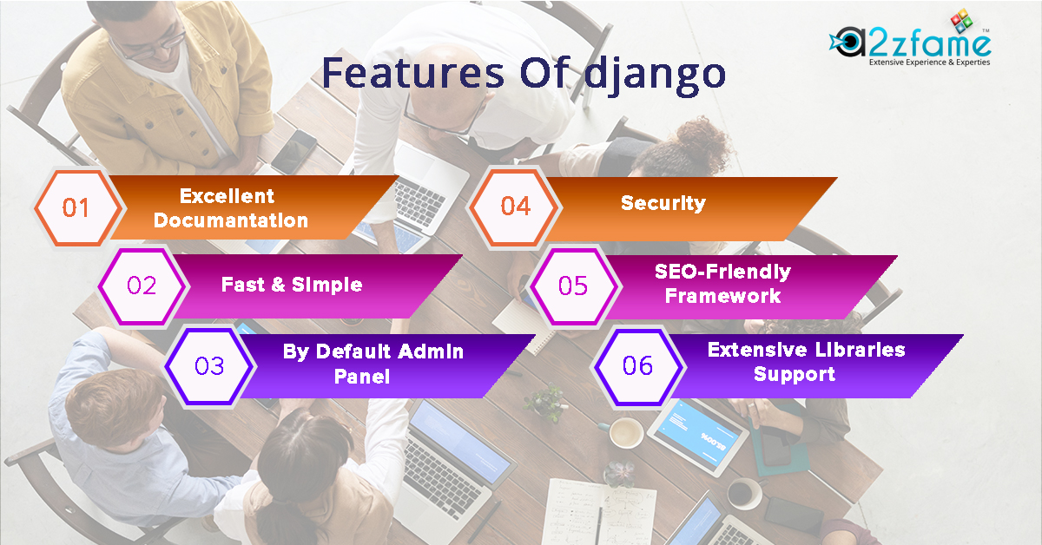

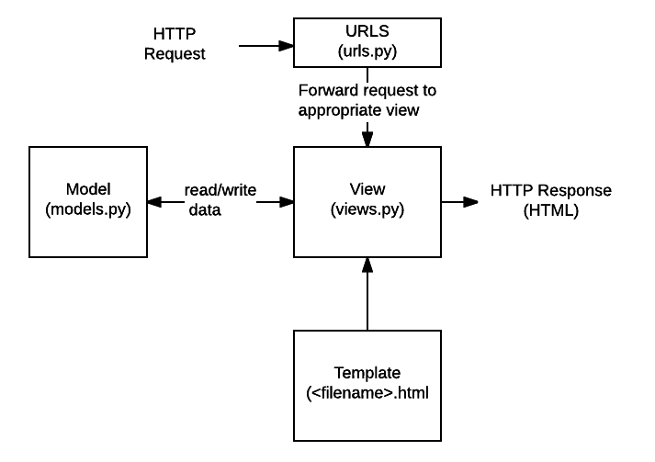

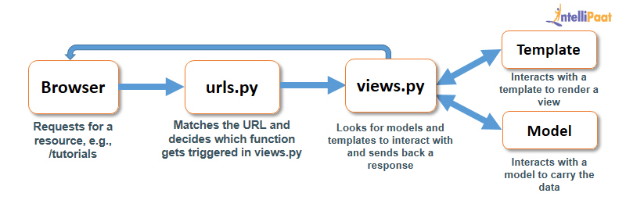

1. Django Query Set

A Query Set is a collection of data from a database.

A Query Set is built up as a list of objects.

Query Sets makes it easier to get the data you actually need, by allowing you to filter and order the data at an early stage.

mydata = Member.objects.all ()

The object is placed in a variable called mydata, and is sent to the template. Member is a model name.